

Assessment - 1

TITLE
Credit Card Fraud Detection Using Machine Learning

Submitted by
Class and Section: ISE – A

Team Lead: Asfareen Parveez – R23EQ009
Khushi P Katwe – R23EQ053
Asfareen Parveez – R23EQ009
Hemanth L – R23EQ042

Under the Guidance of: Ms. Bhavana

Date: 1st December 2025

Credit Card Fraud Detection Using Machine Learning

Abstract
Credit card fraud has become a major challenge in financial security as online transactions continue to increase worldwide. Fraudulent activities are extremely rare compared to genuine transactions, making fraud detection a highly imbalanced classification problem. This project presents a Machine Learning-based approach using the Random Forest Classifier to detect fraudulent credit card transactions. The dataset, containing 284,807 anonymized transactions, exhibits severe class imbalance with only 0.17% fraud cases. To address this, undersampling and feature scaling were applied. The trained model achieved 96.38% accuracy, approximately 90% recall for fraud detection, and an AUC score of 0.9775. SHAP explainability was implemented to interpret model predictions, and a Streamlit web application was developed for real-time fraud prediction. The system demonstrates high effectiveness and practical applicability in financial fraud prevention.

1. Introduction
1.1 Background
With the rise of digital payments, credit card fraud has become one of the most critical challenges in the financial world. Traditional fraud detection systems rely heavily on manual rules or simple statistical models that fail to adapt to evolving fraud patterns. Machine learning techniques, especially ensemble models like Random Forest, offer superior performance due to their ability to learn complex, non-linear patterns from data. Explainable AI tools such as SHAP further improve system transparency, making these models suitable for real-world financial environments.
1.2 Problem Statement
The objective of this project is to build a machine learning model to accurately detect fraudulent credit card transactions in a highly imbalanced dataset while minimizing false negatives, which can lead to severe financial loss.

1.3 Objectives
- To preprocess and analyze a real credit card fraud dataset.
- To address class imbalance using undersampling.
- To develop a fraud detection model using Random Forest.
- To evaluate model performance using accuracy, recall, F1-score, and AUC.
- To interpret model decisions using SHAP explainability.
- To deploy a Streamlit web app for real-time fraud prediction.
2. Literature Review

2.1 Credit Card Fraud Detection Models
Traditional statistical methods such as Logistic Regression, Naïve Bayes, and Decision Trees work effectively for balanced datasets but fail when dealing with extreme imbalance. Modern ML techniques like Random Forest, SVM, XGBoost, and Neural Networks demonstrate superior fraud detection performance.
2.2 Imbalanced Dataset Challenges
Fraud detection datasets contain very few fraudulent cases. This imbalance leads to biased models that classify most transactions as genuine. Techniques such as undersampling, oversampling (SMOTE), and hybrid approaches are used to resolve this. This project applies Random Undersampling.
2.3 Explainable AI (XAI)
Explainability is essential in financial applications. SHAP (SHapley Additive exPlanations) provides insights into how each feature influences model predictions, making ML-based fraud detection transparent and reliable.
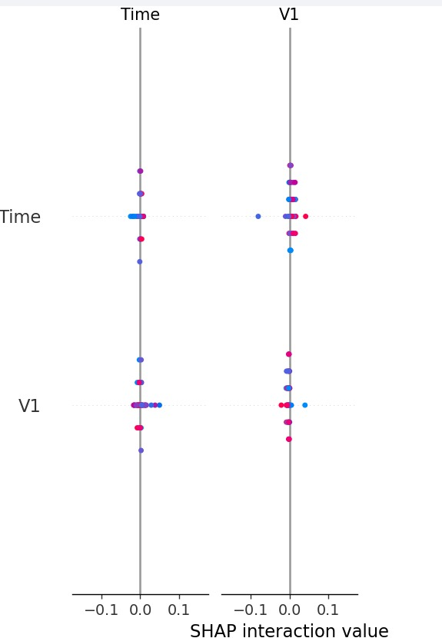

3. Methodology
3.1 Dataset and Preprocessing
The dataset was obtained from the Kaggle Credit Card Fraud dataset. Preprocessing included scaling ‘Amount’ and ‘Time’ using StandardScaler, handling class imbalance through undersampling, and splitting the data into 80% training and 20% testing sets.
3.2 Model Architecture
This project uses the Random Forest Classifier with 50 estimators. Random Forest is chosen for its robustness, ability to handle noise, and capacity to detect complex fraud patterns.
3.3 Model Training and Evaluation
The model was trained on the balanced dataset and evaluated using accuracy, precision, recall, F1-score, confusion matrix, and AUC-ROC score. Recall is prioritized due to the cost of missing fraudulent transactions.

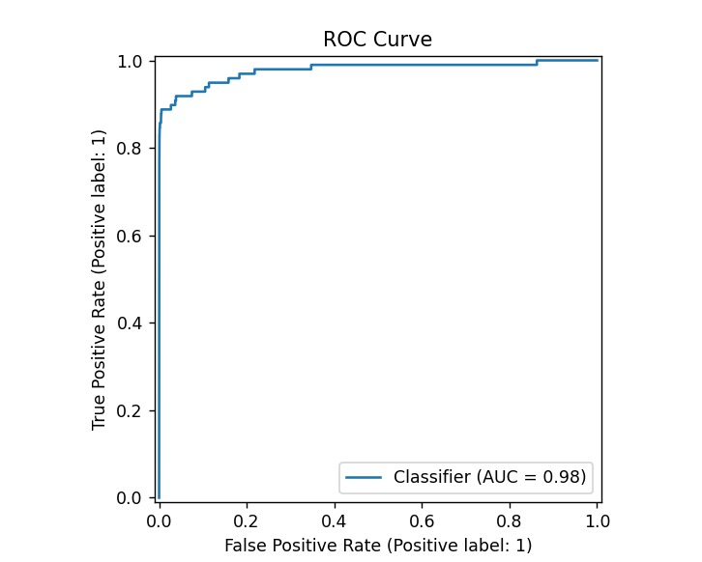
4. Results and Discussion
4.1 Model Performance
The Random Forest model achieved the following performance:
- Accuracy: 96.38%
- Recall (Fraud Class): ~90%
- AUC Score: ~0.9775
The model demonstrated strong capability in identifying fraudulent transactions.

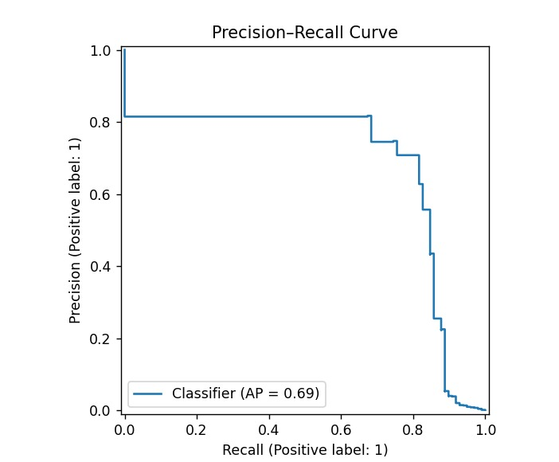
4.2 Explainable AI Results
SHAP summary plots show that features V14, V10, V4, and V12 had the highest contribution to identifying fraud. This improves trust and transparency for financial institutions.
4.3 Streamlit Web Application
The Streamlit app supports two modes:
- Random Transaction Mode: Displays real transaction data with predictions.
- Manual Input Mode: Allows users to input transaction details and predict fraud probability.
Results are color-coded for user clarity.
5. Future Work
Possible improvements include integrating SMOTE-based oversampling, adding deep learning models, incorporating additional transaction-level features, performing live deployment via cloud services, and expanding the dataset.
6. Conclusion
This project proved that machine learning, specifically Random Forest, is effective for credit card fraud detection. With preprocessing, undersampling, and SHAP explainability, the system provides accurate, interpretable, and practical fraud predictions. The Streamlit application makes it ready for real-time use in financial environments.

